# [**Fall TV's Biggest Time Slot Battles: Comedies, Dramas & Reality Face Off**](https://www.tvinsider.com/938804/fall-2020-schedule-time-slot-conflicts/)

[***Meredith Jacobs***](https://www.tvinsider.com/author/meredith-jacobs/)AUGUST 24, 12:40 PM

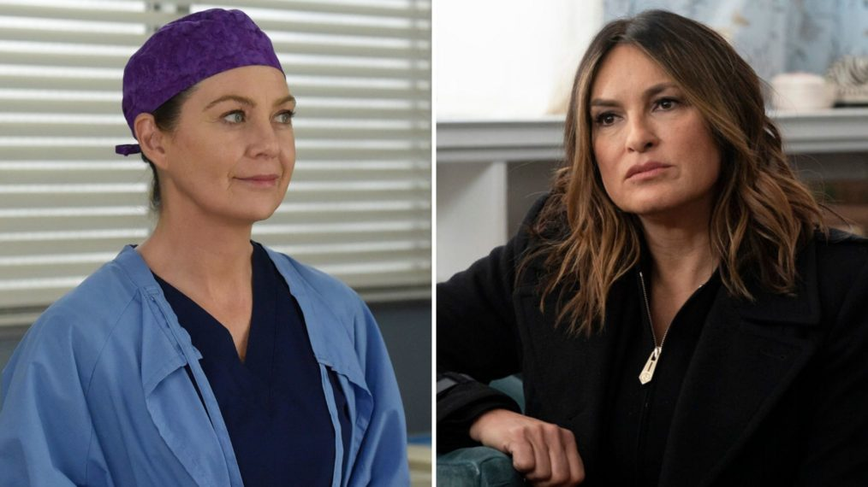

ABC/Bonnie Osborne; Virginia Sherwood/NBC

While only some premiere dates have been announced at this point—and therefore we don't know which shows will actually be airing new episodes opposite one another—the networks have all released schedules for "fall" 2020.

Fans of reality shows and dramas especially are going to have some tough choices to make throughout the week, even with Fox and the CW leaning heavily into acquisitions versus their own original programming.

Below, we break down some of the biggest time slot battles TV viewers could be facing when it comes to what to watch live in the 2020-2021 season.

## **Tuesdays**

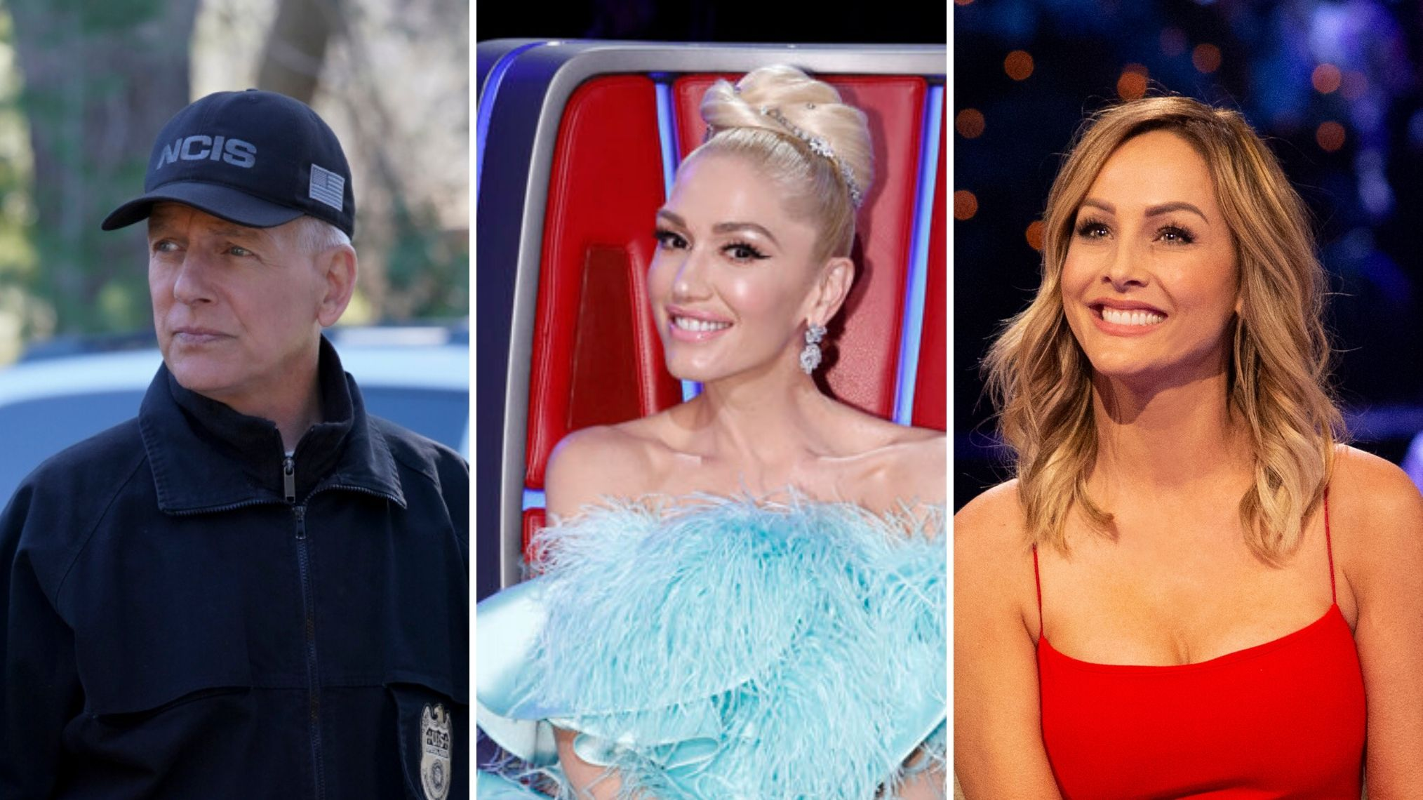

*NCIS* vs. *The Voice* vs. *The Bachelorette* (Sonja Flemming/CBS; Trae Patton/NBC; ABC/Paul Hebert)

### ***NCIS* vs. *The Voice* vs. *The Bachelorette***

[***NCIS***](https://www.tvinsider.com/show/ncis/) always does well at **8 p.m.**, and it does have a longstanding audience as it enters its 18th season. Will *The Bachelorette*'s postponed season with [**Clare Crawley**](https://www.tvinsider.com/people/clare-crawley/) pull anyone away from the CBS drama or [***The Voice***](https://www.tvinsider.com/show/the-voice/) (when it premieres, [**after the delay**](https://www.tvinsider.com/945178/the-voice-season-19-premiere-date-coaches/))?

### ***FBI* vs. *neXt* vs. *This Is Us***

[***This Is Us***](https://www.tvinsider.com/show/this-is-us/) is guaranteed to bring people back for more, because who doesn't love the Pearsons? Or could one of [**Dick Wolf's**](https://www.tvinsider.com/people/dick-wolf/) shows or the new Fox thriller [***neXt***](https://www.tvinsider.com/show/next/) come out on top at **9 p.m.**?

[SEE ALSO](https://www.tvinsider.com/gallery/this-is-us-kevin-randall-best-moments/)

### [**7 of Kevin & Randall's Best Brotherly 'This Is Us' Moments (PHOTOS)**](https://www.tvinsider.com/gallery/this-is-us-kevin-randall-best-moments/)

We list some of our favorites, from breakdowns to brotherly bonding.

### ***FBI: Most Wanted* vs. *New Amsterdam* vs. *Big Sky***

To close out the night at **10 p.m.**, the established medical drama on NBC goes up against one of the newer Wolf offerings on CBS. But it could be David E. Kelley's new thriller, *Big Sky*, that draws people in as one of the few new shows joining the fall lineup.

## **Wednesdays**

### ***The Amazing Race* vs. *The Masked Singer* vs. *Chicago Med***

A [**One Chicago**](https://www.tvinsider.com/show/one-chicago/) offering is always likely to keep people tuning in, especially if there's a crossover happening. But people also love watching and guessing which celebrities are competing in a season of [***The Masked Singer***](https://www.tvinsider.com/show/the-masked-singer/). And there's always the possibility that people want to see what's happening over on [***The Amazing Race***](https://www.tvinsider.com/show/the-amazing-race/) after the [**delay**](https://www.tvinsider.com/932641/the-amazing-race-season-32-delayed-game-on-tough-as-nails-cbs/). Or could [**Patrick Dempsey**](https://www.tvinsider.com/people/patrick-dempsey/) [**back on U.S. television**](https://www.tvinsider.com/937004/patrick-dempsey-devils-cw-fall-2020/) in the CW's acquired *Devils* be of interest to some at **8 p.m.**?

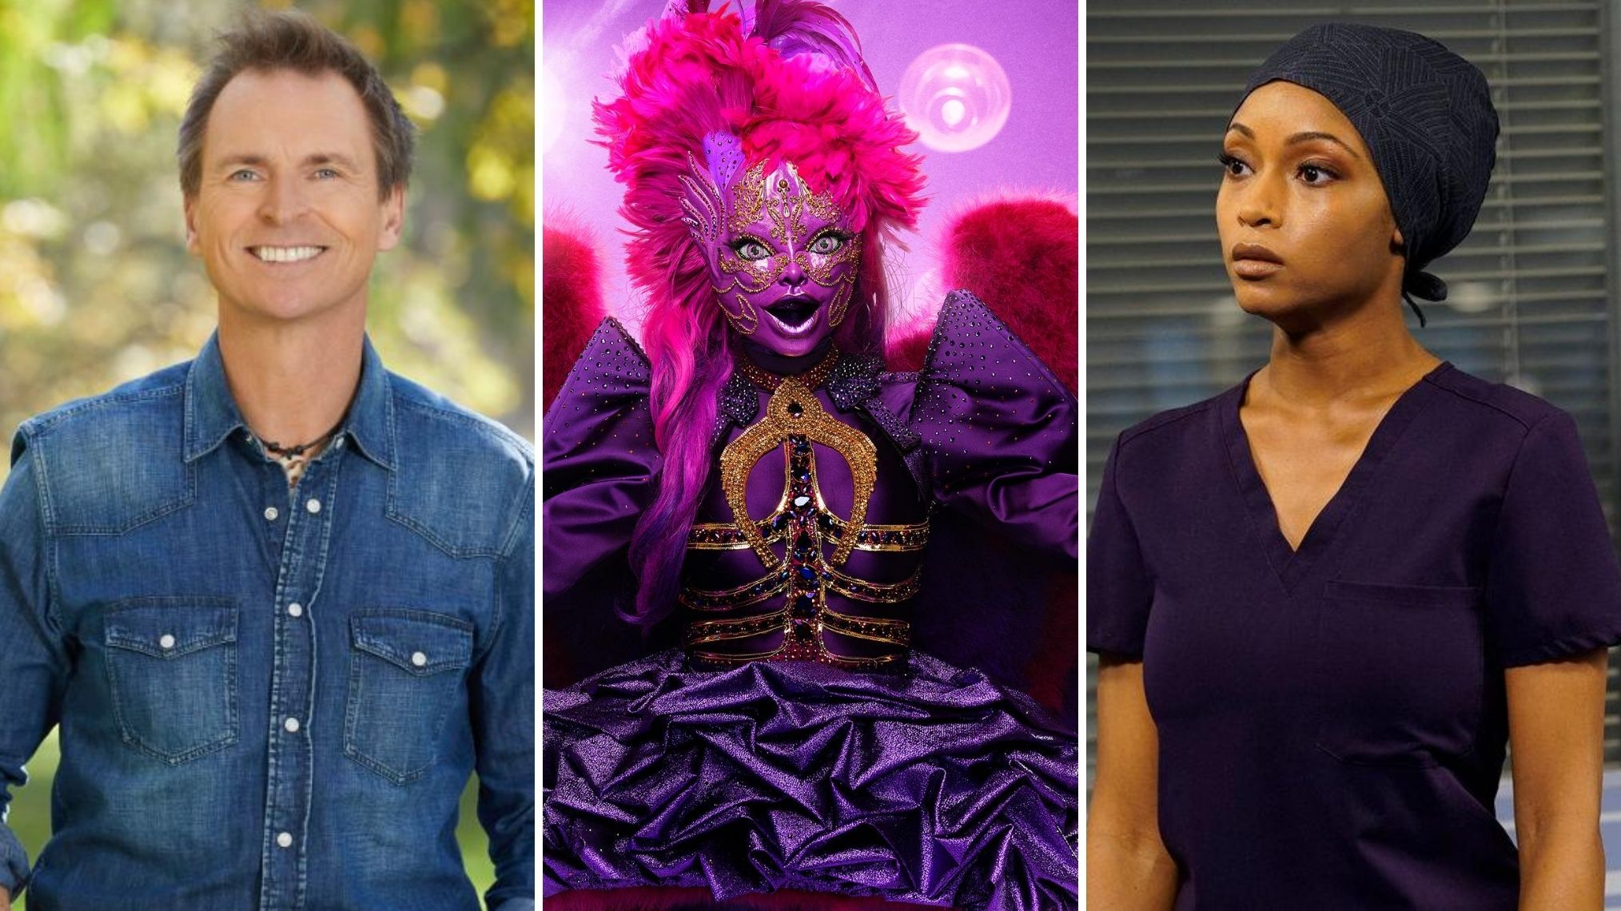

*The Amazing Race* vs. *The Masked Singer* vs. *Chicago Med* (Sonja Flemming/CBS; Michael Becker/FOX; Elizabeth Sisson/NBC)

### ***S.W.A.T.* vs. *Chicago P.D.* vs. *Stumptown***

With [***Survivor*'s**](https://www.tvinsider.com/show/survivor/) upcoming season [**delayed**](https://www.tvinsider.com/941821/survivor-delayed-swat-cbs-fall-2020-schedule/), [***S.W.A.T.***](https://www.tvinsider.com/show/s-w-a-t/) was moved up to the fall (from the originally planned midseason return). Procedural fans are going to have a decision to make at **10 p.m.**: the [**Shemar Moore**](https://www.tvinsider.com/people/shemar-moore/)-led CBS drama, more One Chicago with [***P.D.***](https://www.tvinsider.com/show/chicago-p-d/) or the more character-driven [***Stumptown***](https://www.tvinsider.com/show/stumptown/)?

## **Thursdays**

### ***Young Sheldon* vs. *Superstore* vs. *Station 19* vs. *Supernatural***

The good news is, there's something on at **8 p.m.** for fans of pretty much every genre. The bad news is there's quite a bit to watch. If you're looking for comedy, CBS and NBC have you covered. If you're more of a procedural, first-responder kind of person, look to ABC's [***Grey's***](https://www.tvinsider.com/show/greys-anatomy/) spinoff. And if you'd rather see how it all ends for hunters Sam (Jared Padalecki) and Dean Winchester (Jensen Ackles) with the [**final seven episodes**](https://www.tvinsider.com/934619/supernatural-return-final-episodes-season-15-finale/), tune in to the CW. (If you like sports, Fox has football.)

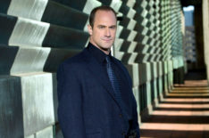[SEE ALSO](https://www.tvinsider.com/938476/stabler-law-order-svu-spinoff-organized-crime/)

### [**Stabler Spinoff 'Law & Order: Organized Crime' Gets Fall 2020 Premiere**](https://www.tvinsider.com/938476/stabler-law-order-svu-spinoff-organized-crime/)

Find out more about the 'devastating personal loss' that brings Christopher Meloni's character back to the NYPD.

### ***Law & Order: SVU* vs. *Grey's Anatomy***

Captain Olivia Benson ([**Mariska Hargitay**](https://www.tvinsider.com/people/mariska-hargitay/)) or surgeon Meredith Grey ([**Ellen Pompeo**](https://www.tvinsider.com/people/ellen-pompeo/))? Crime or medicine? Two of the longest running dramas—each has broken a record in their genres—compete at **9 p.m.** This may be one of the toughest choices of the season.

### ***Evil* vs. *Law & Order: Organized Crime* vs. *A Million Little Things***

[**Christopher Meloni's**](https://www.tvinsider.com/people/christopher-meloni/) return to television as Elliot Stabler is likely going to draw quite a few people to the newest [***Law & Order***](https://www.tvinsider.com/show/law-order/) at **10 p.m.**, at least initially. But dramas [***Evil***](https://www.tvinsider.com/show/evil/) and [***A Million Little Things***](https://www.tvinsider.com/show/a-million-little-things/) could easily retain their audiences, especially after each ended with major cliffhangers. How worried should we be about Kristen's ([**Katja Herbers**](https://www.tvinsider.com/people/katja-herbers/)) soul and Eddie ([**David Giuntoli**](https://www.tvinsider.com/people/david-giuntoli/)) surviving?

## **Sundays**

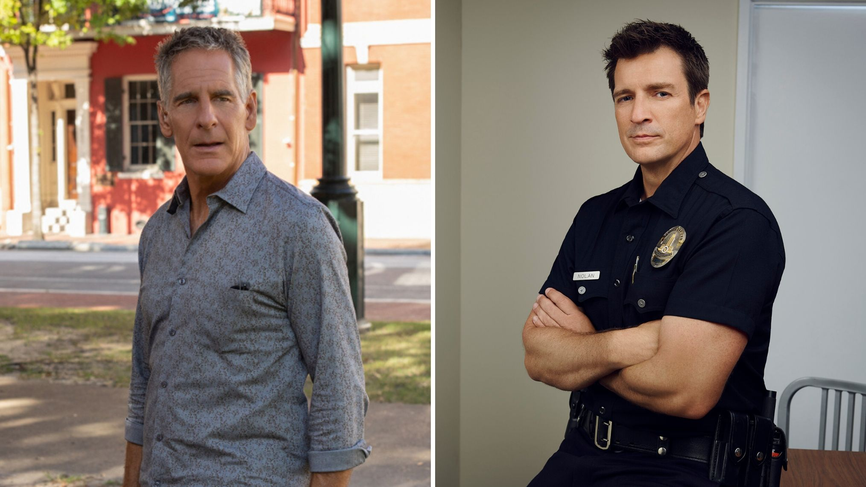

*NCIS: New Orleans* vs. *The Rookie* (Sam Lothridge/CBS; ABC/Andrew Eccles)

### ***NCIS: New Orleans* vs. *The Rookie***

If you're a fan of procedurals, you might have to make a choice at **10 p.m.** Will you tune in to the agents of NOLA's [***NCIS***](https://www.tvinsider.com/show/ncis/) spinoff or [**Nathan Fillion**](https://www.tvinsider.com/people/nathan-fillion/) and the rest of the cops of ABC's drama?